**Week 4**

**1, My learning**

* 1. Mind map of class notes

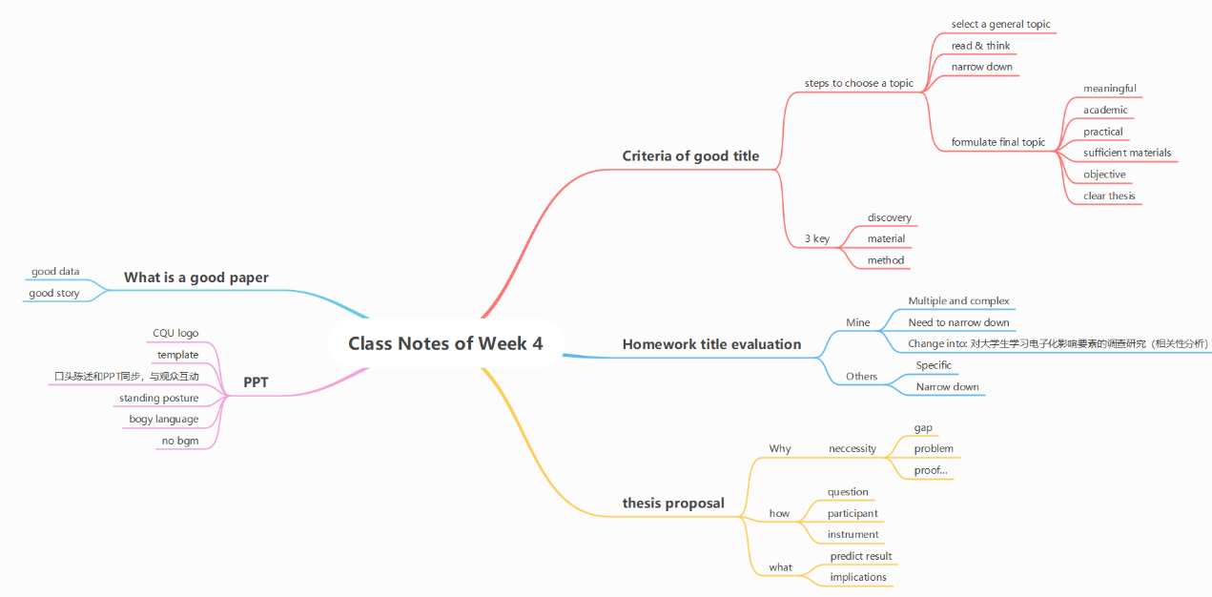

* 1. Prepare for thesis proposal. Make PPT.

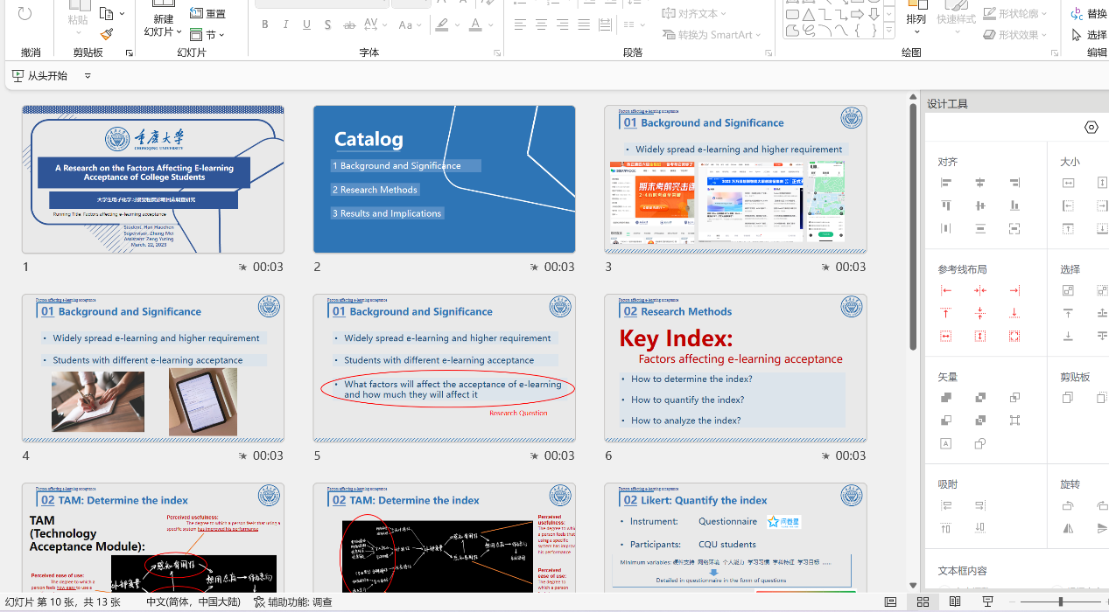

**2, Learning outcomes**

* Exercise making PPT and make it more beautiful.
* Challenge myself to give lecture without looking at the paper.
* Better my title and learn the criteria of a good title.

**3, My behavior and attitude**

**1）Out of Class**

1.1 Autonomous learning

1.1.1Online

* Listen to Ted

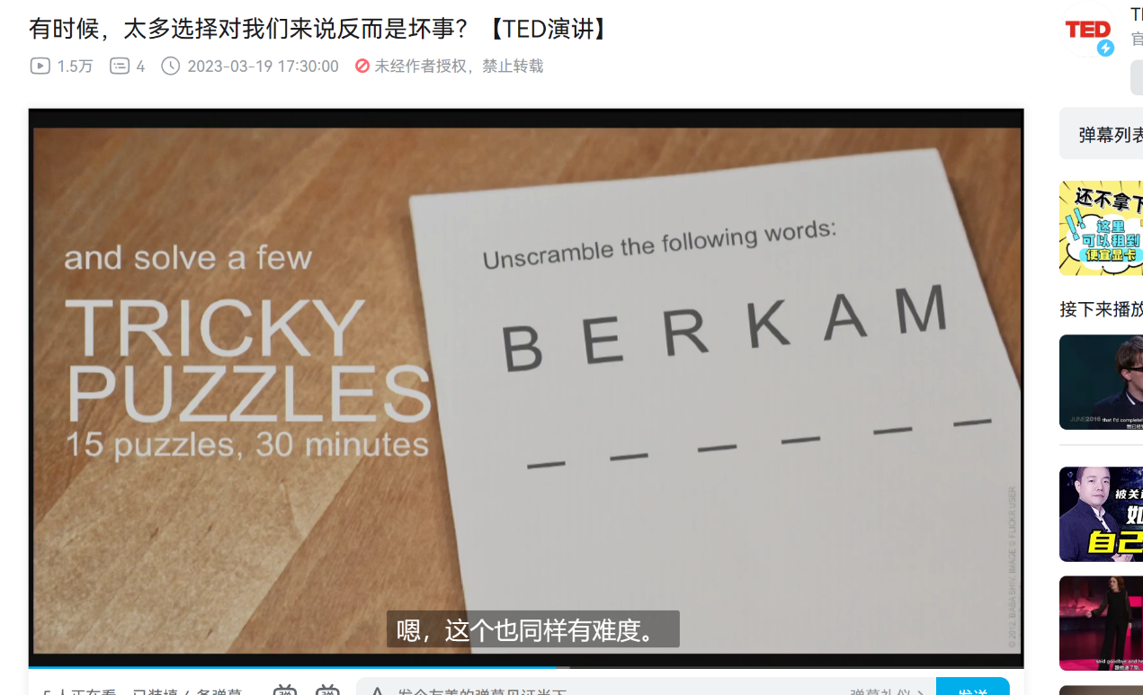

* Watch English movies

1.1.2 Offline

* Read National Geography

1.2 Homework

* Mind map
* Prepare for thesis proposal

1.3 Cooperative learning

* Collect PPT of group members
* Encourage group members to discuss in QQ group

**2）In Class**

2.1 Individual performance

* Take notes
* Answer questions

**4．Improvement**

**1）Out of Class**

1.1 Autonomous learning

* Improve listening
* Vocabulary

1.2 Homework

* Read faster

**Week 5**

**1, My learning**

* 1. Evaluation of classmates’ thesis proposal

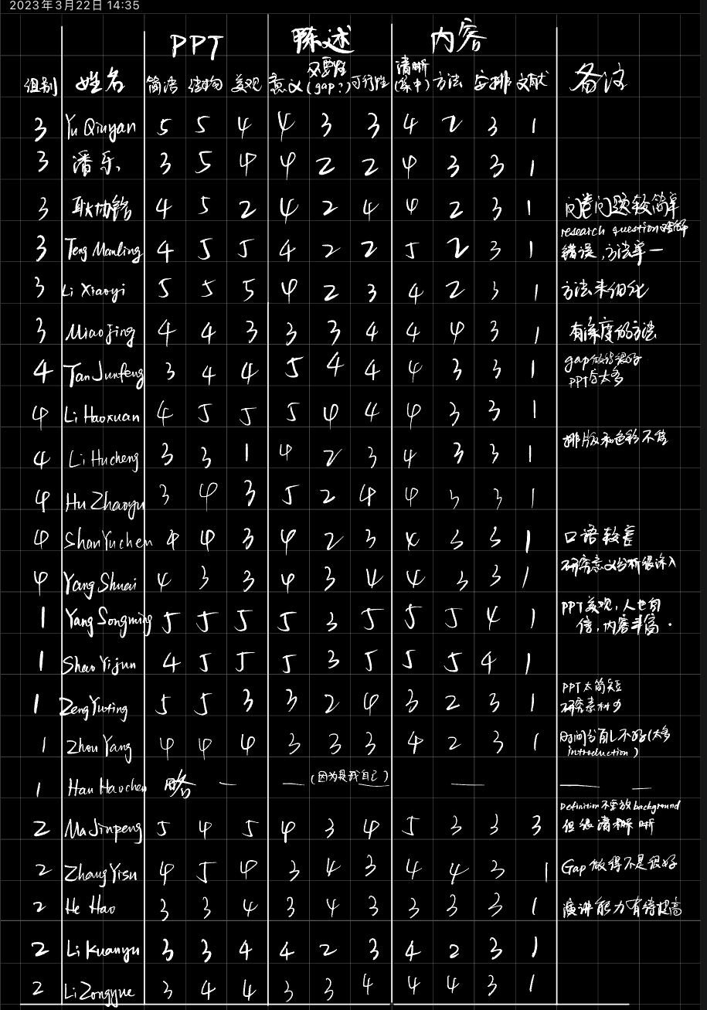

The five-point rating scale of evaluation

**Overall evalution:**

Many students did not distinguish between Research Question and questionnaire question, and did not make clear the necessity of their research in the proposal report, because they did not do literature review, or did not explore the gap between their own research and past research. In addition, when introducing the questionnaire survey, the number and type of respondents covered should be given. The above also has a feedback effect on my proposal report

* 1. My thesis proposal

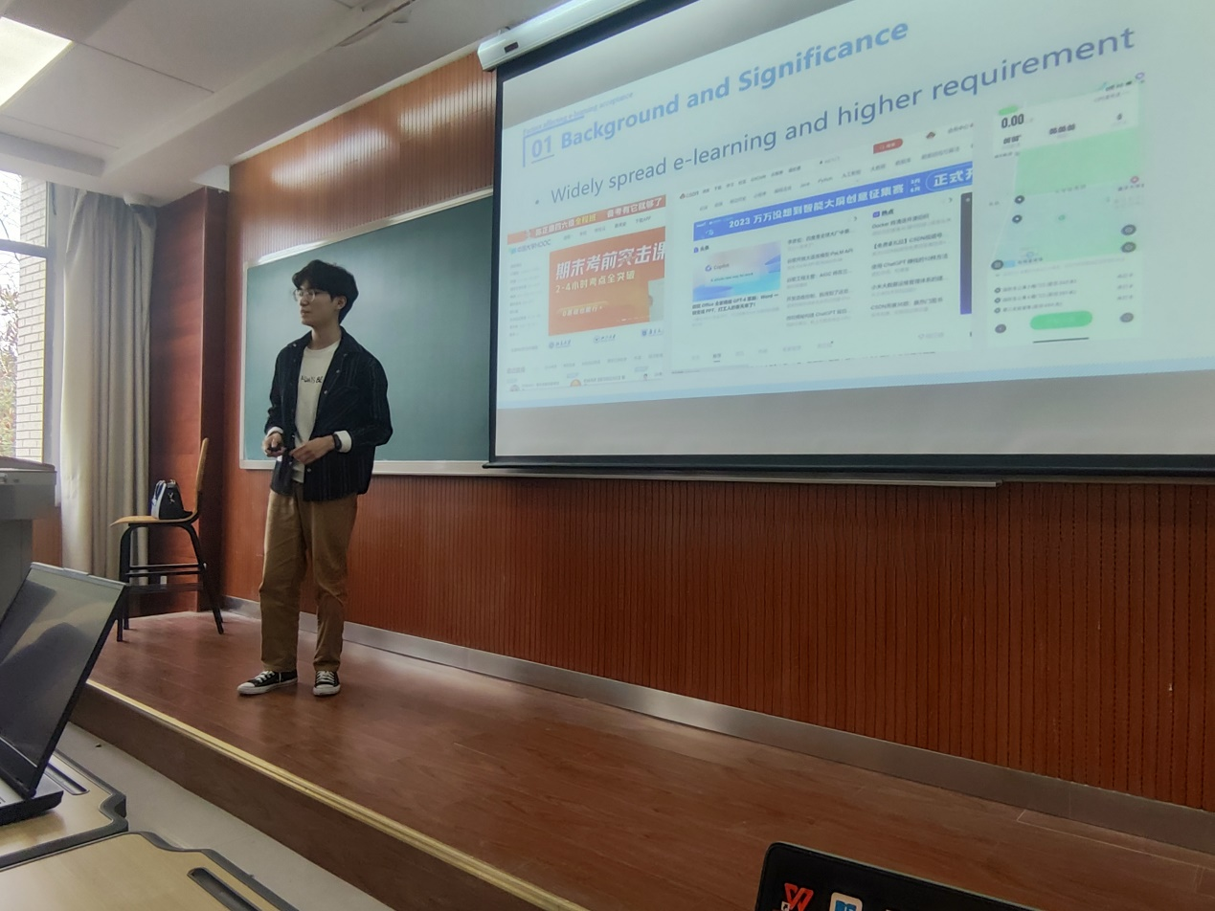

* 1. Mind map of “Introduction”

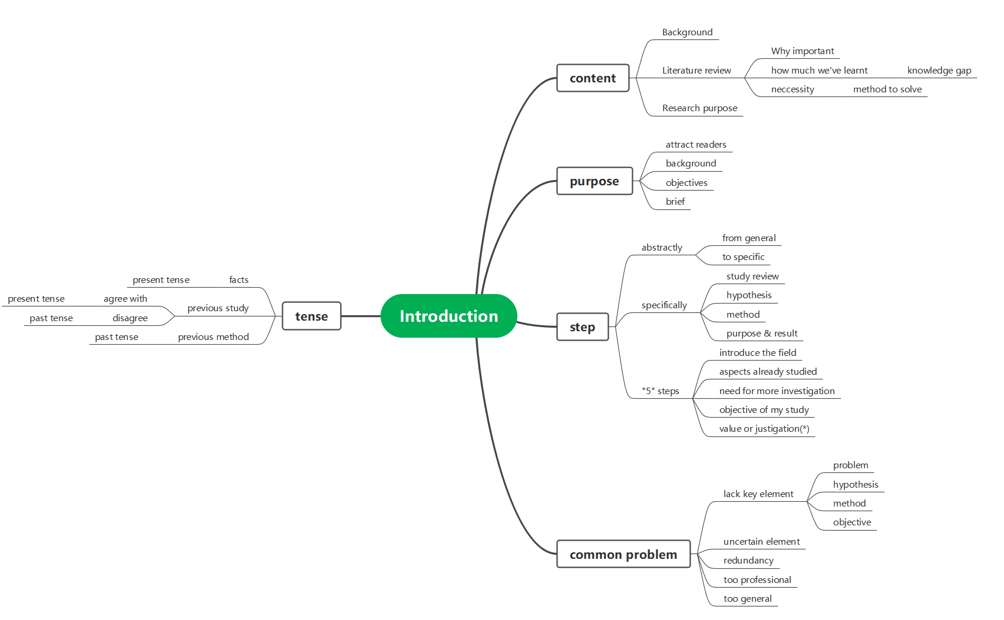

**2, Learning outcomes**

* A good introduction is half the success of a paper
* Introduction should let the reader understand the research background, research purpose, research necessity
* Steps of writing introduction should be from broad to specific.

**3, My behavior and attitude**

1.1 Autonomous learning

1.1.1Online

* Listen to Ted



* Watch English movies

1.1.2 Offline

* Read National Geography
* Read literature relative to my research

1.2 Homework

* Mind map
* Evaluation of thesis proposal

1.3 Cooperative learning

* Encourage group members to discuss writing introduction in QQ group

**Week 6**

**1, My learning**

* 1. class notes

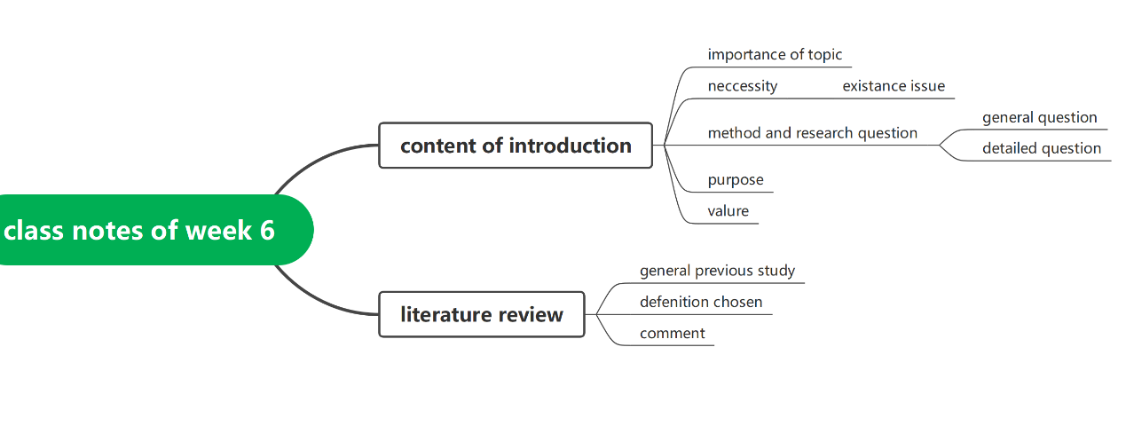

1.2 Write Introduction part of my research

First, write the draft:

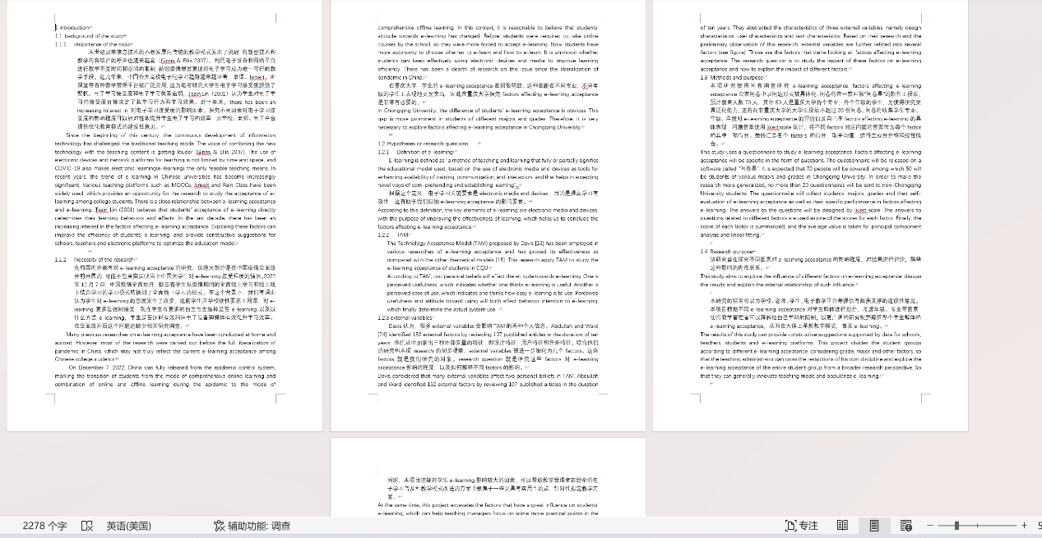

Then, write the draft into the body and convert it to the correct format. Insert pictures

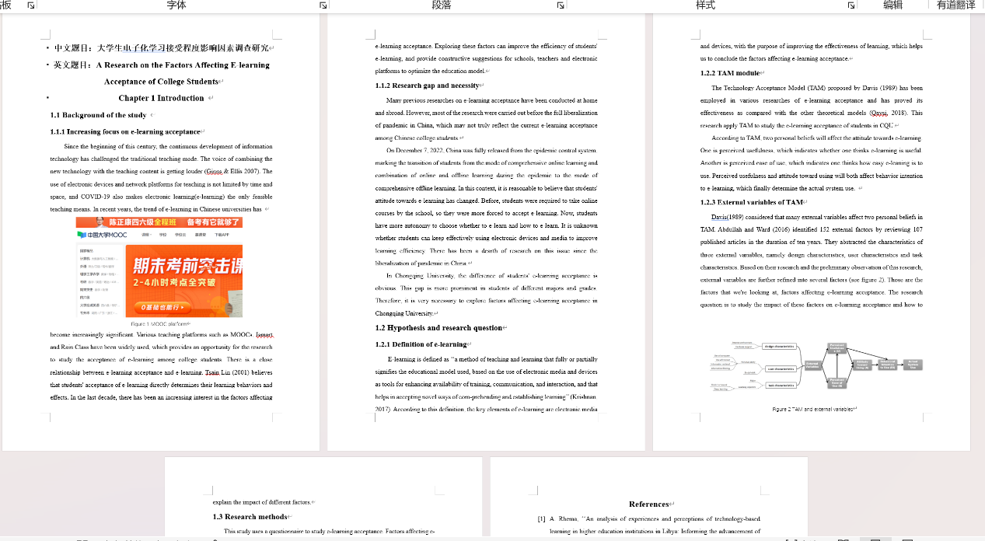

At last, learn to make references

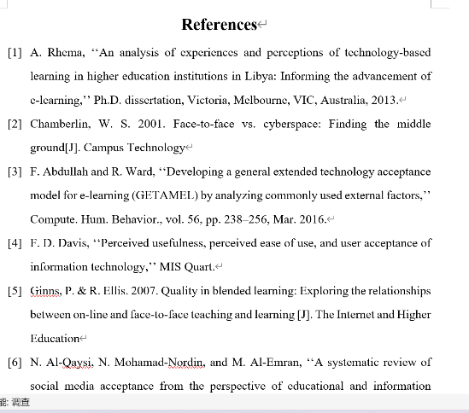 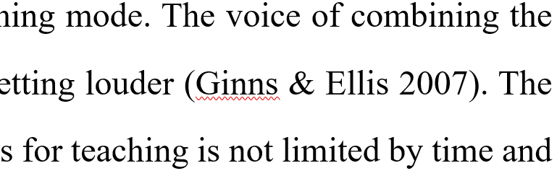

Now, I’ve finished an introduction section with 1245 words!

**2, Learning outcomes**

* Learn to write introduction section. The contents of the introduction section learned in class were written into my article
* Learn to write papers in the correct format
* Learn how to write reference and carry out practise

**3, My behavior and attitude**

**1）Out of Class**

1.1 Autonomous learning

1.1.1Online

* Listen to Ted



* Watch English movies-1917

1.1.2 Offline

* Read National Geography

1.2 Homework

* Mind map
* Write Introduction part

1.3 Cooperative learning

* Collect Introduction writing of my group members

**2）In Class**

2.1 Individual performance

* Take notes
* Answer questions

**4．Improvement**

**1）Out of Class**

1.1 Autonomous learning

* Improve listening
* Vocabulary

1.2 Homework

* Read faster